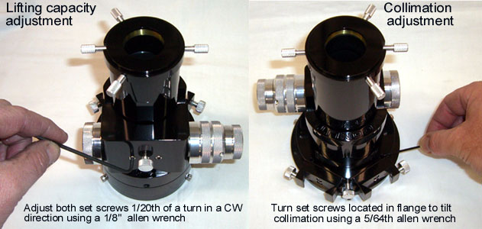
MoonLite Focuser - Adjustments & Maintenance

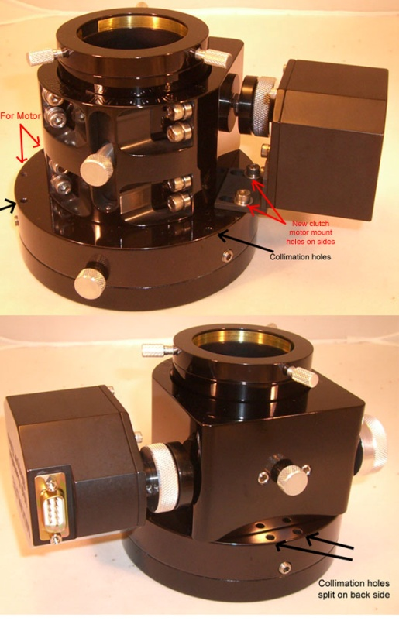
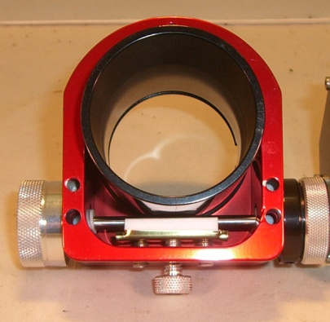
- Lifting Capacity: The drawtube pressure can be adjusted to each user’s preference. Increasing the pressure increases the load capacity (vertical lifting capacity) of the focuser. Decreasing the pressure lowers the load capacity but gives the focuser a smoother focusing action. We set the focuser at approximately 5 lbs. at time of assembly; however, you can adjust it to be more depending on your specific needs. The ideal setting is to have it adjusted so the focuser can hold the heaviest load presented without slipping and requiring no additional force. This will give the focuser the best feel and still provide the vertical lifting capacity required. To adjust the lifting capacity, turn the aluminum thumbscrew located between the two setscrews on the bottom of the focuser clockwise (CW) to increase load capacity. The aluminum thumbscrew can only add pressure, not take away pressure. This is due to the 2 setscrews on each side of the thumbscrew applying a minimum set pressure amount. In some rare case it may be necessary to do a coarse adjustment by turning the 2 setscrews located on each side of the aluminum thumbscrew (1/8 Allen wrench is needed) a very small amount. Normally, 1/20th of a turn or less should be made on the setscrews in a CW direction, then check the lifting capacity pressure by racking the drawtube up and down with your heaviest load. Note: excessive pressure adjustment over 1/20th of a turn can crack the bearings!
- Collimation: To adjust collimation, turn the 4 mini setscrews located in the top part of the 2-part flange. A small amount of tip/tilt (.015 max) can be made by adjusting the 4 setscrews. We check collimation on each focusers before shipping so no adjustment should be required; however, if collimation is required due to some sort of problem when the focuser is installed, then the tip/tilt ability of the focuser's flange will come in handy. The rule of thumb is that less then 1 degree of tip/ tilt error is tolerated by modern EPs. Use a 5/64th Allen wrench down in the set screw access holes to adjust the tip/ tilt of the upper flange to the lower flange. The set screws are nylon tipped and can prey the upper flange away from the lower flange making a small gap between the 2 flanges. Please note the set screws are roughly positioned in a 3 point fashion, but the rear back side position is split in to 2 set screws side by side to avoid an existing mounting set screw located at that location. Collimation holes are indicated in black on the photos.
- Performance: To maintain the CF focusers performance, keep all bearing and shaft riding surfaces clean on the drawtube. All crayford style focusers require a clean bearing to drawtube surface for smooth operation. The drawtube has been polished to remove all machine marks and hard anodized resulting in the action having a super smooth feel. Keeping the surfaces clean will keep the focuser operating at optimal performance. Note: Some wear marks on the drawtube are normal over regular use and do not cause any performance issue; however, excessive wear marks on the drawtube can be seen if the drawtube is not clean. Airborne contaminates on the drawtube surface can get crushed between the bearings and the drawtube surface. The crushed particles will be abrasive causing the drawtube’s anodized surface to wear quicker than normal. Please keep the drawtube clean, especially in sandy/windy areas.

- Reduction Unit: Dual rate focuser owners may want to break in the 8:1 reduction unit by running it up and down when first receiving the focuser. It is adjusted fairly tight at the time of assembly and requires a little use to come up to peak performance. No maintenance should be required on the reduction unit as it is packed with lithium low temperature grease for the life of its operation.

Motor adjustments

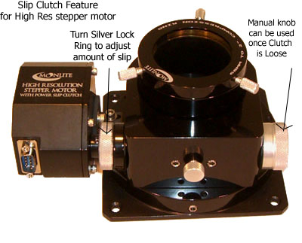
The amount of slip can be adjusted on the slip clutch by adjusting the tightness of the slip clutch ring. For manual knob operation of the focuser, turn the silver knurled ring loose. For motor operation of the focuser, tighten the silver knurled ring. To adjust the knurled rings tension, it helps to hold the manual knob still with your right hand and turn the clutch ring with your left hand. Holding the manual knob in place will keep the shaft from turning, allowing the clutch ring to tighten/loosen the clutch

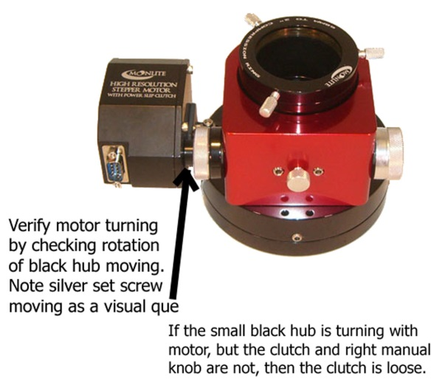
Focuser adjustment guide for motor options if focuser slips under heavy loads. Slipping can be caused be either a loose clutch setting or drawtube to shaft pressure setting to low.
First-- check the slip clutch. Does the manual knob move when turning it by hand ?
If it moves easily, then the clutch is loose. The manual knob should be very hard to move manually when the clutch is tight. Tighten up the clutch.
Second --- Check the drawtube tension (lifting capacity). Please be sure clutch is tight in above step, then check the drawtube to shaft tension by taking your hand and pushing on the drawtube to make it slip. The force needed to make the drawtube slip should be greater than your heaviest load used. If it slips easily, then increase the drawtube pressure ( lifting capacity adjustment ).
Visual inspection--
If the manual knob on the right does not turn when the focuser motor is running,( tighten clutch as shown in motor documentation). If the manual knob on the right is moving but the drawtube is not moving, then the drawtube is slipping and the shaft to drawtube pressure needs increased a small amount. See lifting capacity adjustment shown above.
To verify motor is moving in case of a cabling problem, check the black hub part of the clutch that is connected to the motor shaft for motion. If you look carefully at the black nub that attaches to the motor shaft, you may be able to see it turn as a small silver set screw should be noted turning around with the black hub. The black hub is on the left side of the slip clutch. The black larger pad side of the clutch is set screwed on to the main shaft. As the motor turns the small black hub part of the clutch will move with it. It is set screwed on to the motor shaft. This is a good way of testing to see if the motor is actually moving. The whole clutch as a unit should rotate with the motor if it is tight. If it is loose, then only the small hub on the motor side will be turning with the motor.
Moonlite Telescope
www.focuser.com

