MoonLite Focuser Installation Instructions for Coronado Solar Max 60 II
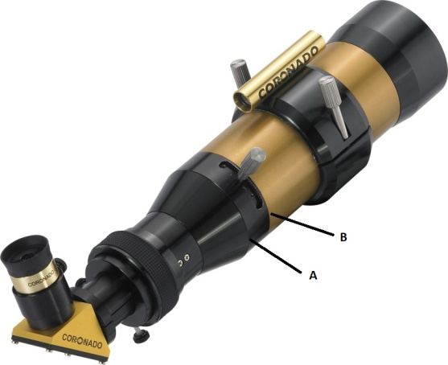

- Unthread the stock focuser from the OTA at point A, not B.
- Remove threaded internal lens from the stock focuser.
- Carefully unscrew silver etalon tuning lever and remove the internal etalon; mark which radial hole the tuning lever was connected to.
- Thread and tighten the internal lens to the bottom of the MoonLite focuser.
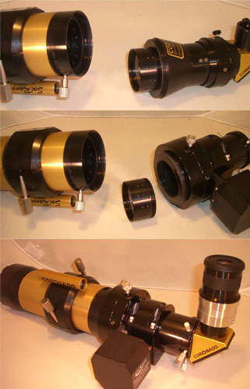
- Thread on, but do NOT FULLY TIGHTEN the etalon onto the internal lens. This avoids trying to engage two threads at the same time later.
- Thread the MoonLite focuser onto the OTA.
- Use a pin to carefully rotate the etalon to reveal the marked radial hole in the tuning slot; screw the silver etalon tuning lever back into the etalon. It may be necessary to use a different hole in some cases due to thread differences.
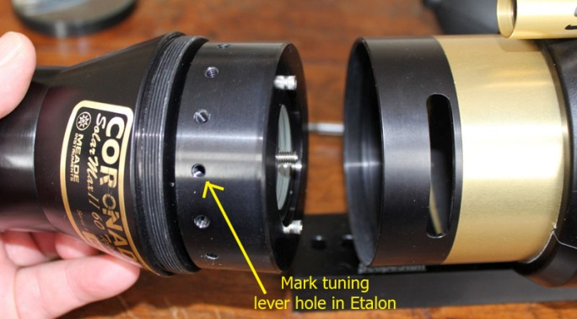

Please Note: Some production runs of both 60mm and 90mm
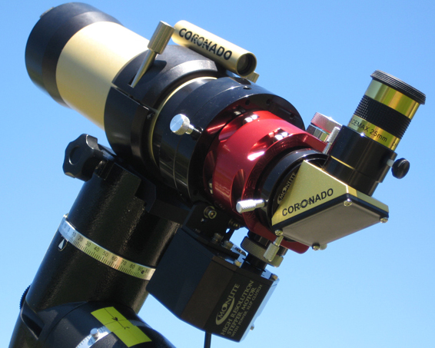
OTAs had the rear lens glued in place. It can be removed
and re-glued into the MoonLite flange, just as the original configuration.

MoonLite Telescope Accessories
755 Preserve Road, Danville, PA 17821-7909
Phone/Fax (570)437-2232
www.focuser.com

