Coming soon MoonLite CXL 3.6” Extra Large Format Crayford
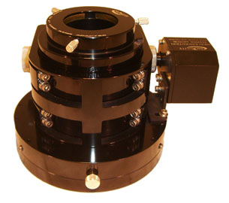
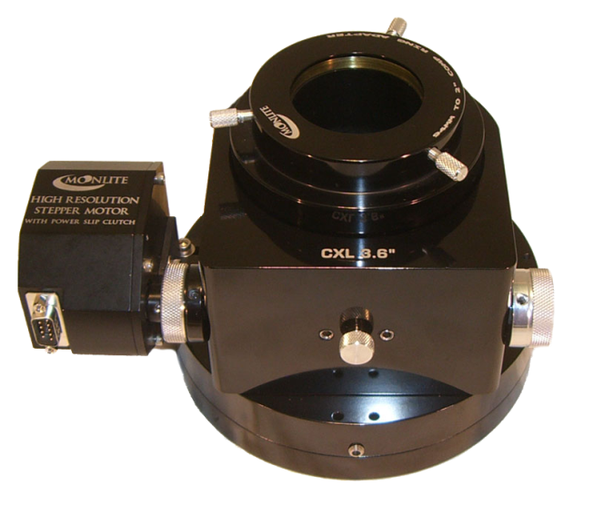

The CXL 3.6” Extra Large Format focuser is available with our manual dual rate with shaft lock option. It is also available with our high resolution stepper motor/Mini V2 controller, and high resolution stepper motor/DRO dual port controller and rotator. The CXL comes in one of six anodized colors (red, black, blue, green, gold or violet). Rotator option will be available shortly for the CXL Model. Features an 8lb load capacity.

- Dual Rate with Shaft Lock $670.00
- High Resolution Stepper Motor with Mini V2 Controller $1010.00
- High Resolution Stepper Motor with DRO Dual Port Controller and Rotator (2 axis) $1745.00
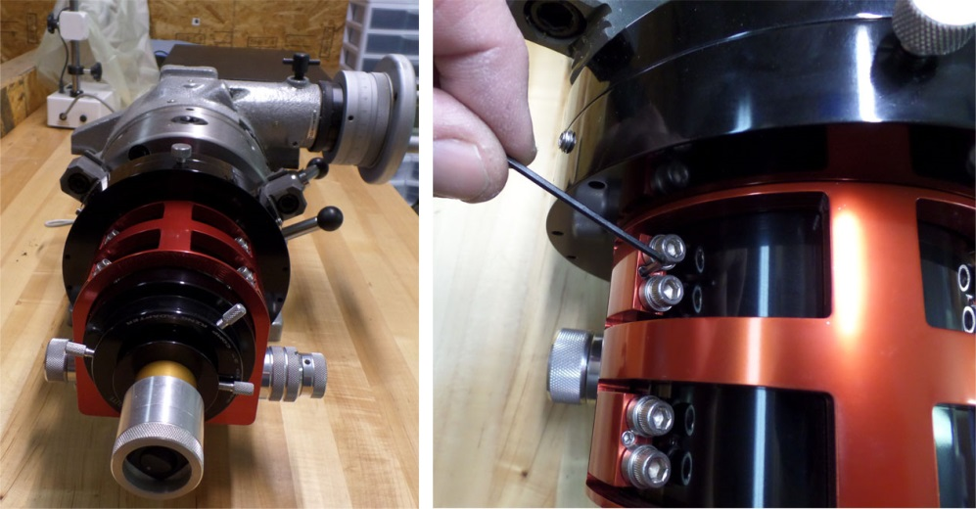
It Features a 2 point collimation system for perfect alignment ability. Both bearing to drawtube tilt/ tip collimation, and also upper to lower flange rotation tilt/ tip collimation.
Example, a laser is placed in the focuser then the focuser is spun on a rotatory table bolted to our test bench. The focuser’s drawtube collimation is adjusted with turning one or more of the 4 bearing location adjustment set screws. The laser dot will hit center of target and spin on its self without cutting a circle. Secondary collimation of the upper to lower flange is also available with tip / tilt set screws located on the upper flange.
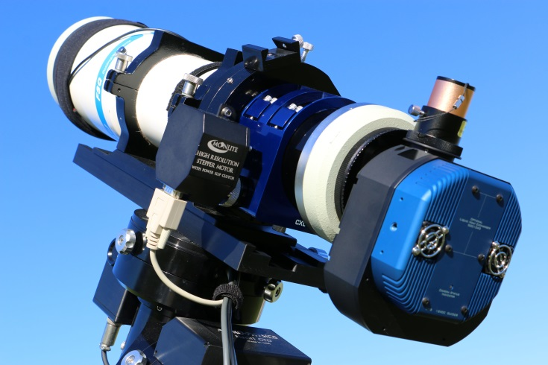
The Drawtube has a 94mm x 1mm female thread on top and comes in 4 sizes.
--1.5” travel
-- 3” travel
--4” travel
--5” travel
Threaded flanges are available in different sizes
--RC10” and 12” thread size
--TAK FSQ106 full OTA thread size
--TAK TOA130 full OTA thread size
--TAK 4” focuser thread size for TOA150 with 125mm x1mm
--Orion EON 130 3” focuser thread
--Flat and curved flanges for Newts
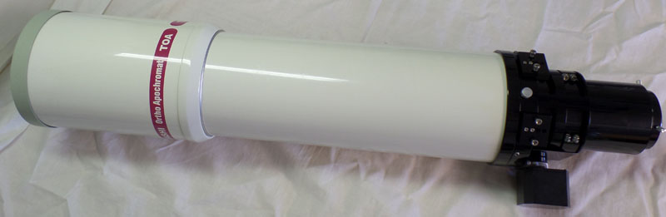
CXL focuser shown installed on TAK TOA 130.

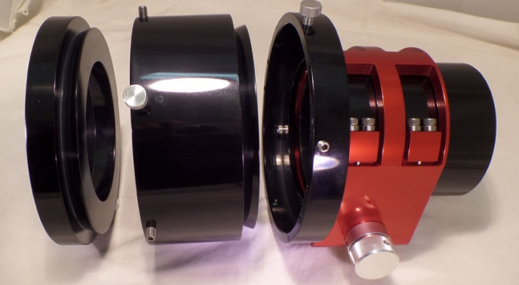
Moonlite also makes a 2.5” flange extender to increase the focuser profile if needed. It installs between the Upper and lower flange on the Moonlite focuser. $99

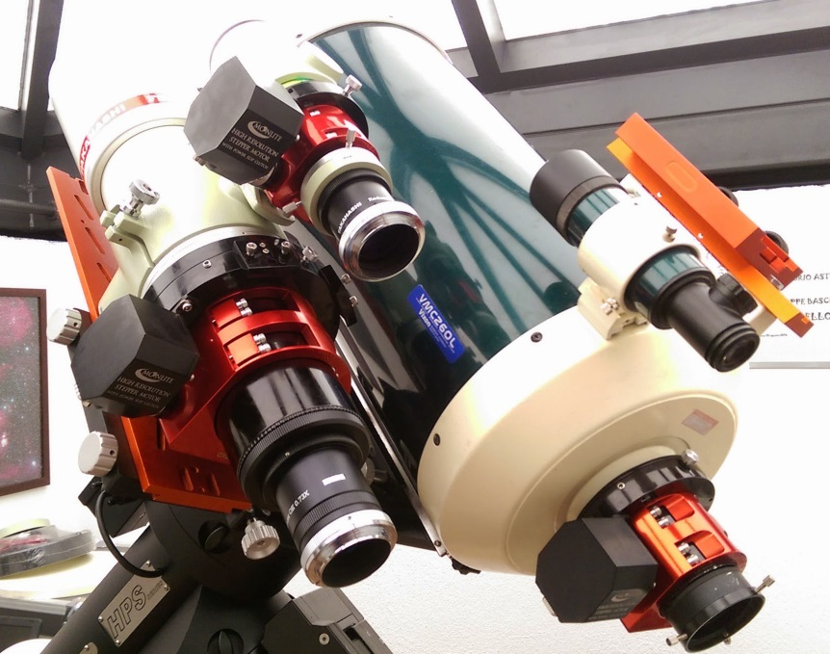

Moonlite focuser models shown in 3 sizes--
CS 2” format on TAK60C
CSL 2.5” large format on Vixen 260
CXL 3.6” extra-large format on TAK106

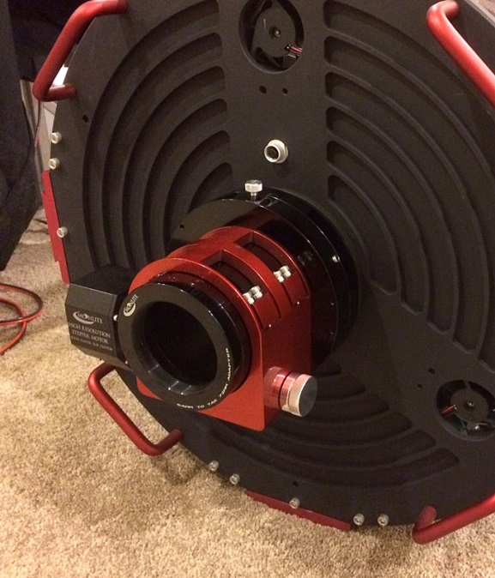

CXL Focuser on 20”RC with following Configuration
Color – Red
Flange - RC 10” 12” 117mm X 1mm thread standard
Drawtube – 1.5” travel 94mm thread top
Knob/Motor = High res stepper motor with slip clutch

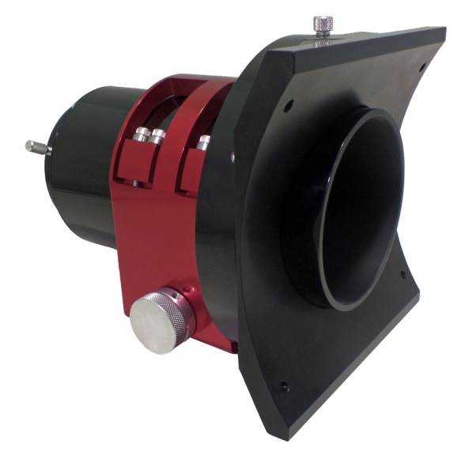
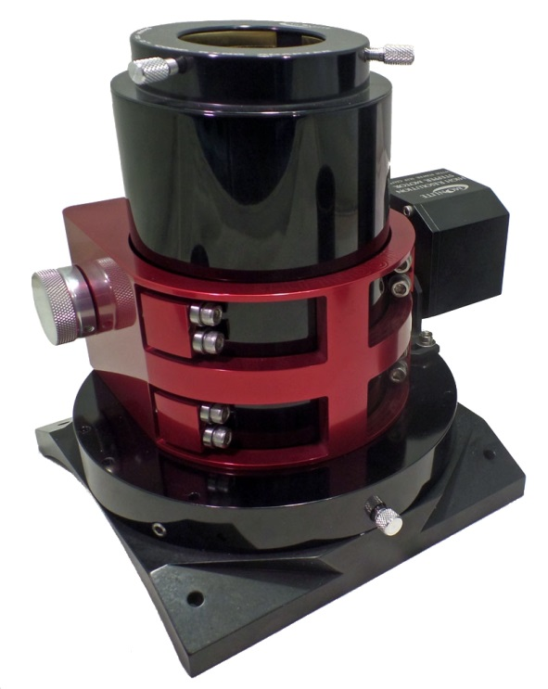

CXL Focuser configured
With 10” curved flange for Newtonian Installation

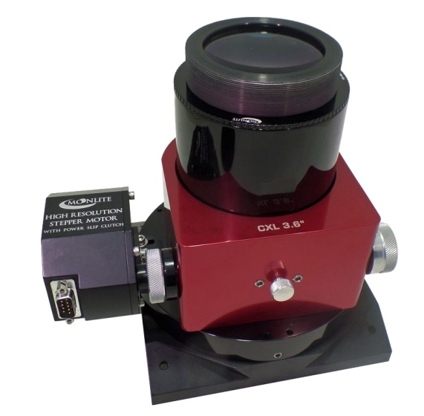

3” Wynne corrector shown Installed using a 94mm to 3” Wynne corrector thread adapter. This example is using a 4” travel drawtube.

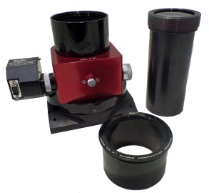

Please note: Clear aperture of the Moonlite CXL 3.6” extra-large format focuser is larger than the stock TAK 4” focuser’s ID.

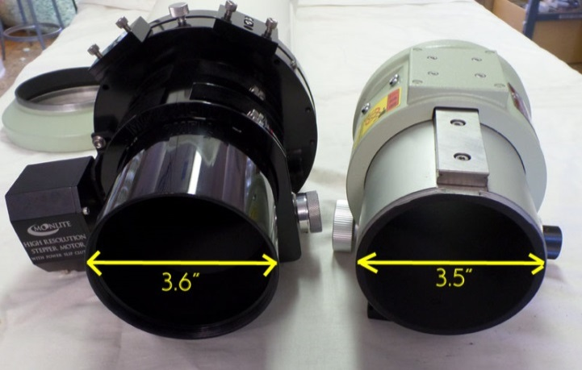

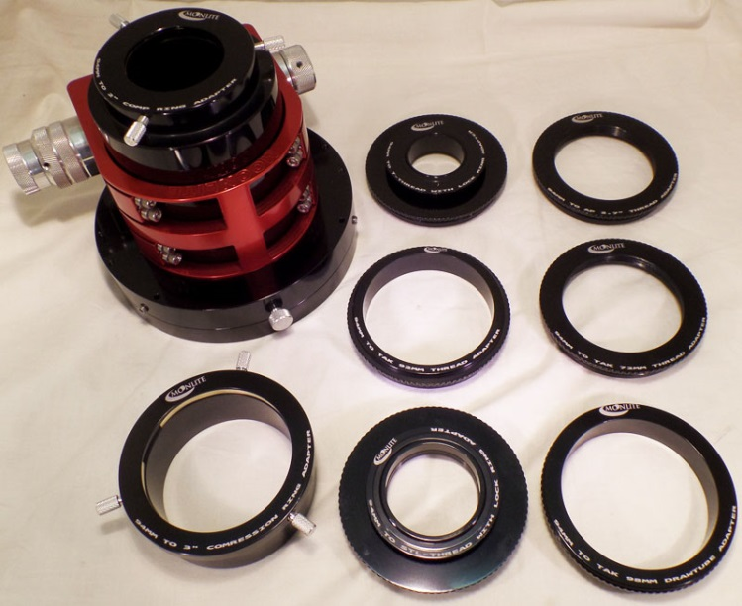
The 94mm threaded drawtube has many thread in top options for connecting Cameras, TAK accessories, and all other typical size threads needed for a rigid all threaded connection. $89 each

Here is a list of some of the Thread in top adapters---

-94mm to 2” comp ring ( comes free with focuser)
-94mm to 3” comp ring ( for new 3” super large wide angle Eye Piece made by ES)
-94mm to TAK 98mm Male drawtube thread emulator ( allows TAK camera rotator to thread on)
-94mm to TAK 92mm Male camera Rotator thread ( allows TAK accessories to be used without the rotator)
-94mm to TAK 72mm
-94mm to T-thread with lock ring
-94mm to STL-thread with lock ring
-94mm to 48mm Filter thread with lock ring
-94mm to AP 2.7”
-94mm to ATIK camera thread
-94mm to 3” Wynne corrector thread
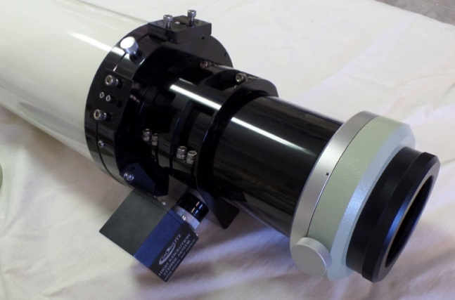

TAK accessories can connect directly to Moonlite focuser drawtube, or to stock TAK camera rotator

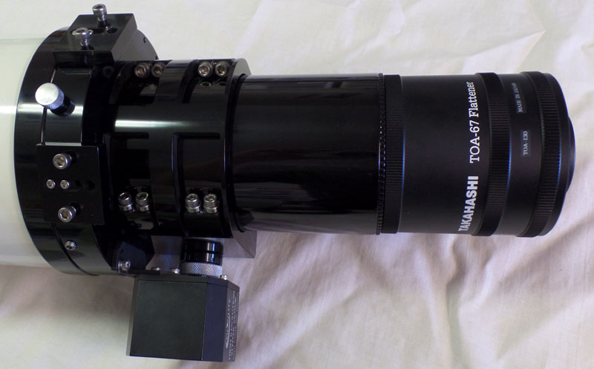
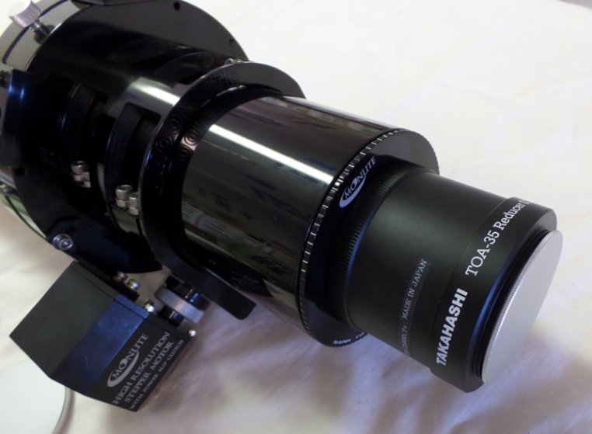
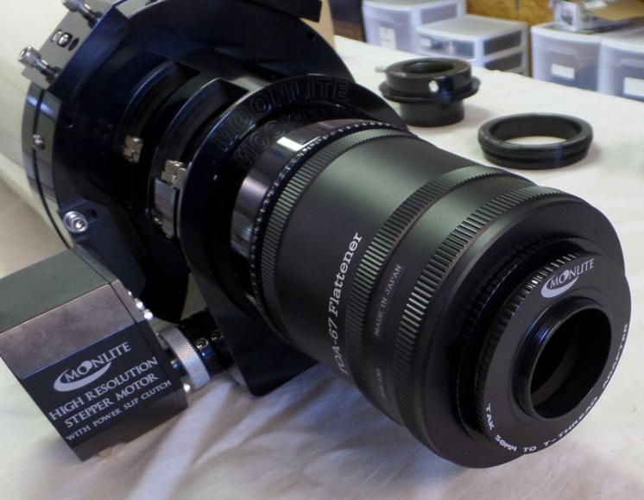

Special Moonlite TAK 53mm to T-thread with lock ring adapter

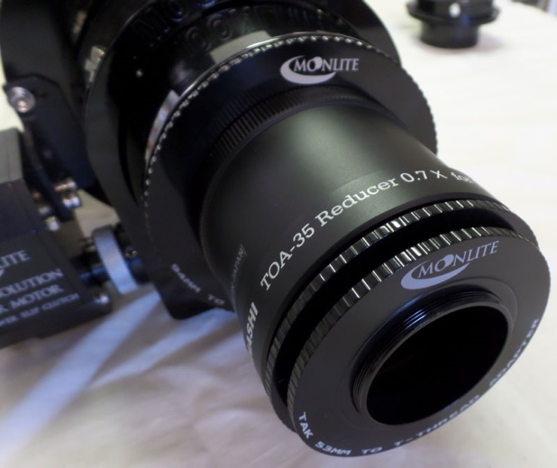

Special Moonlite TAK 50mm to T-thread with lock ring adapter

MoonLite Telescope Accessories
755 Preserve Road
Danville, PA 17821-7909
570-437-2232
www.focuser.com

